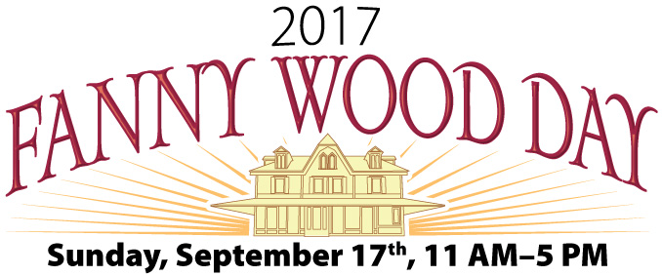
SPONSORS & ADVERTISERS NEEDED
Come join the fun by being a 2017 Fanny Wood Day sponsor or advertiser! Advertisers will be included on our website, WWW.FANNYWOODDAY.COM, for the entire year. A postcard mailer will go out to all Fanwood Residents of the website and it will be prominently posted on the Borough’s website.
Funds through advertiser dollars are used to support a number of family friendly activities such as our popular Scavenger Hunt, Ice Cream Eating contest, Pizza Eating contest, water balloon toss and more. In previous years, funds were used toward replacement of the train station sign board with a new electronic board, purchase of a stage which is used by all departments throughout Fanwood, and a large projection screen used for children’s movie nights in the park.
HELP MAKE A DIFFERENCE IN FANWOOD!!
Advertisers and sponsors should complete this form and return it by mail or drop off at Borough Hall with your full payment to:
Fanwood Borough Hall, ATTN Fanny Wood Day,
75 N. Martine Ave., Fanwood, N.J. 07023
IMPORTANT!! Clean, camera-ready artwork should be emailed to:
bzakarin@comcast.net
Ads received without full payment will not be included on the website or as a sponsor.

Business Name: ________________________ Telephone: __________________________

Contact Name: _________________________ Fax: ___________________________

Address: ___________________________________________________________________

Email: _____________________________________________________________________

Website: ___________________________________________________________________
(For hyperlink attachment to logo)
Please check the level of sponsorship you wish to purchase:

_____ $500.00 Contest Sponsors / 1 year on Front Page of Website, Sponsor
Page of Website and Posters (before deadline)
_____ $100.00 Sponsors / 1 year on Sponsor Page of website

*** DEADLINE: Friday, August 25th, 2017 ***

